Project 15-1: Managing Risk Through Copying Data—Backups
Estimated Time: 25 minutes
Objective: Copy user data to the cloud using backups.
Description: For users who want to manage their risks from a cyber incident, arguably the most important first step is to make a copy of their data. Once a copy of data is safely in place, additional steps can and should be taken. For home users, the best data copy approach is a cloud-based journaling solution. All data is stored online in the cloud for quick and easy retrieval. In this project, you create an iDrive account and create an online backup as a scheduled event.

Note: Types of data copies are covered in Module 13.

- Use your web browser to go to www.idrive.com.
- Scroll down and click the Mini category. Note that iDrive offers a free tier and you do not need a credit card or make any payments for this tier.
- Click the Free 10 GB tab.
- Enter the requested information to create an iDrive account.
- Read the information about encryption. If necessary, select Default encryption key, although for more security, you can use the Private encryption key instead. Click Continue.
- Wait for the iDrive file application to download, launch that file, and then click Accept and Install.
- Select one or more folders for online backup (to select multiple folders hold down the CTRL key and click the folders). Click Backup Now.
- Click View Log to see the information about the backup and click Close when finished.
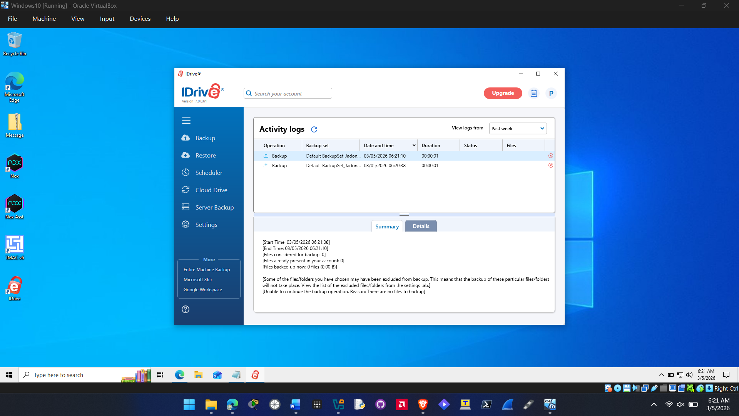
- In the left pane, click Restore. You can restore the backup by selecting one or more of the files or folders.
- Click the Scheduler button in the left pane.
- Select the backup start time and start days for the backup.
- If necessary, click Email notification to receive verification of the backup.
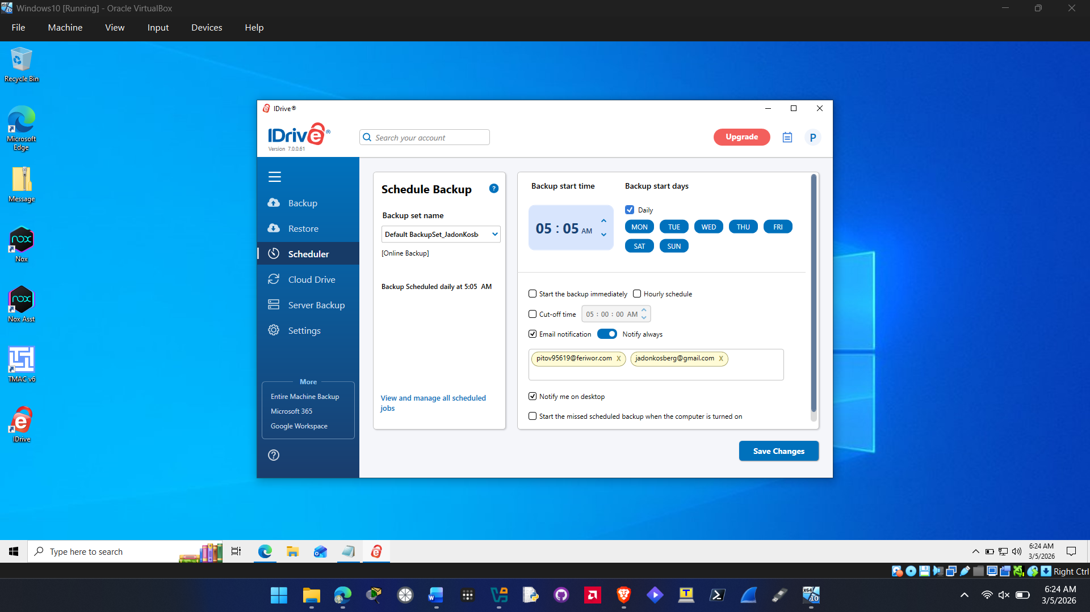

- Click the question mark next to Notify on failure and read through this information. Is “5%” an appropriate setting? When would you adjust it higher or lower?
Yes 5% would be an appropriate value the program lets you set a value of 1-10% for the cut off setting. You would adjust it lower if you want a lower percentage of your files backed up before getting cut off or higher if you do not care about the higher percentage of files being cut off.

- If necessary, click Notify me on desktop to receive a notification through the iDrive application about the backup.
- Click the check box next to Start the missed scheduled backup when the computer is turned on to launch the backup if your device was off when the backup had been scheduled to begin.
- Click Save Changes.
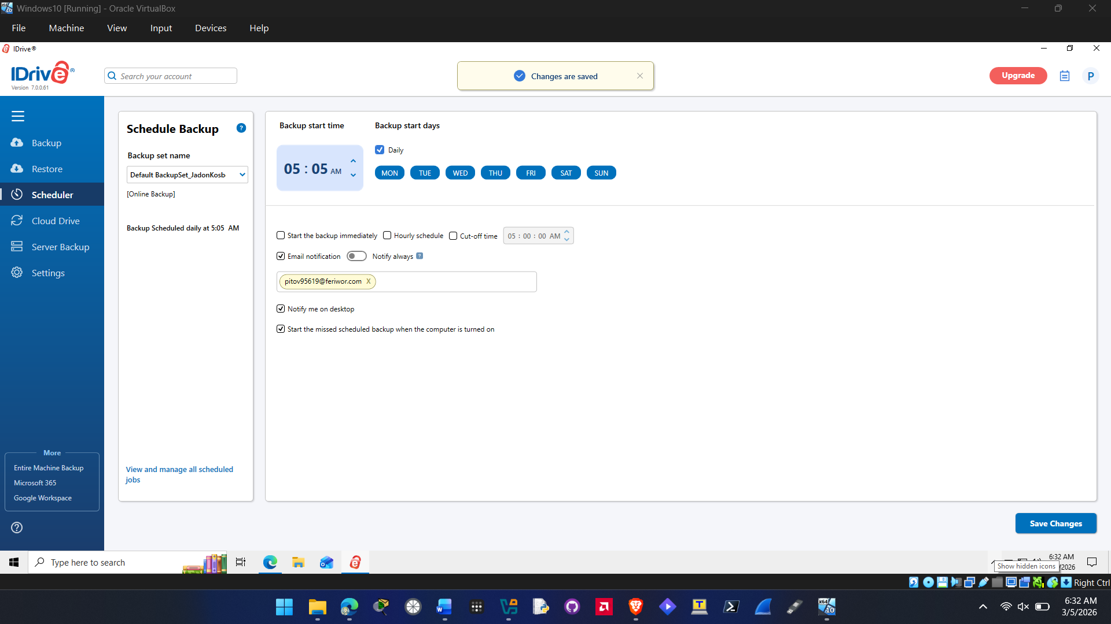
- Remain in iDrive for Project 15-2.

Criteria | Meets Requirements | Needs Improvement | Incomplete
Content | The assignment clearly and comprehensively addresses all questions in the assignment.  15 points | The assignment partially addresses some or all questions in the assignment.  8 points | The assignment does not address the questions in the assignment.  0 points
Organization and Clarity | The assignment presents ideas in a clear manner and with strong organizational structure. The assignment includes appropriate content, coverage of facts, arguments, and conclusions.  10 points | The assignment presents ideas in a mostly clear manner and with some organizational structure. The assignment includes appropriate content, coverage of facts, arguments, and conclusions.  7 points | The assignment does not present ideas in a clear manner or with a strong organizational structure. The assignment includes some appropriate content, but coverage of facts, arguments, and conclusions are not logically related and consistent.  0 points
Research | The assignment is based upon appropriate and adequate data collection and analysis of results from the activity or research from academically reliable sources.  5 points | The assignment is based upon adequate data collection and includes some analysis of results from the activity or research from academically reliable sources.  3 points | The assignment is not based upon appropriate data collection and includes no analysis of results from the activity or research from academically reliable sources.  0 points
Grammar and Spelling | The assignment has two or fewer grammatical and spelling errors.  5 points | The assignment has three to five grammatical and spelling errors.  3 points | The assignment has more than five grammatical and spelling errors, is incomplete, or is unintelligible.  0 points

